# Agenda for Staff Meetings

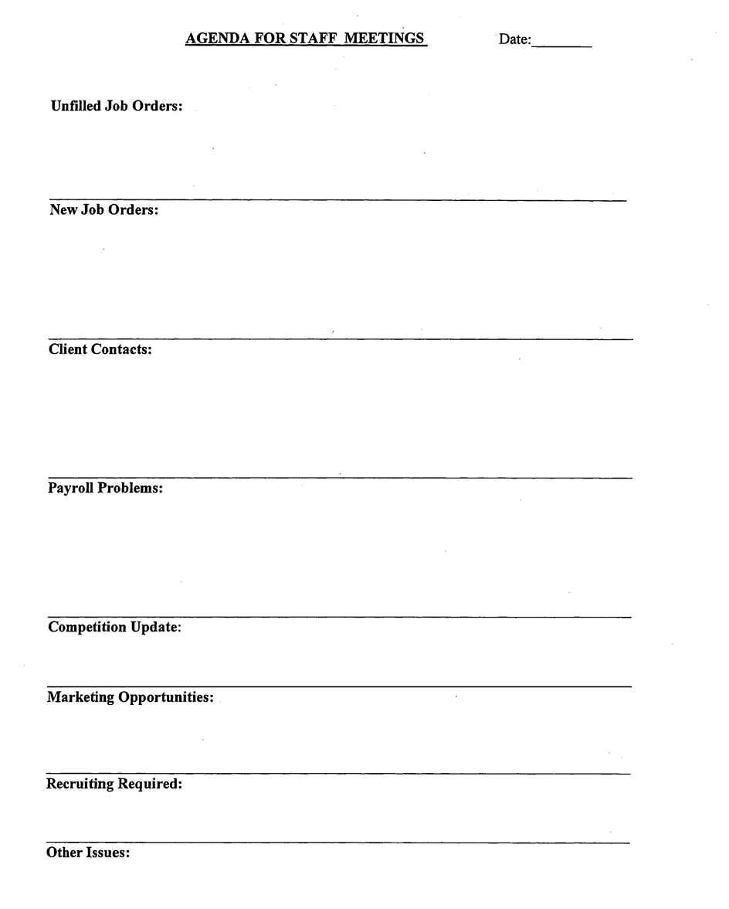

# Weekly Marketing Plan

# Weekly Action Plan

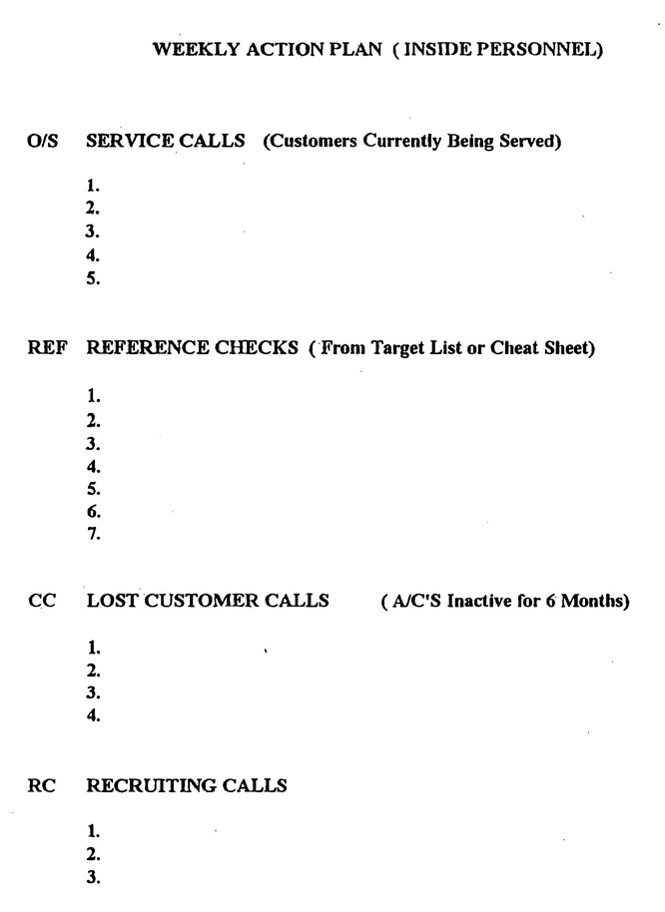

# Daily Order Log

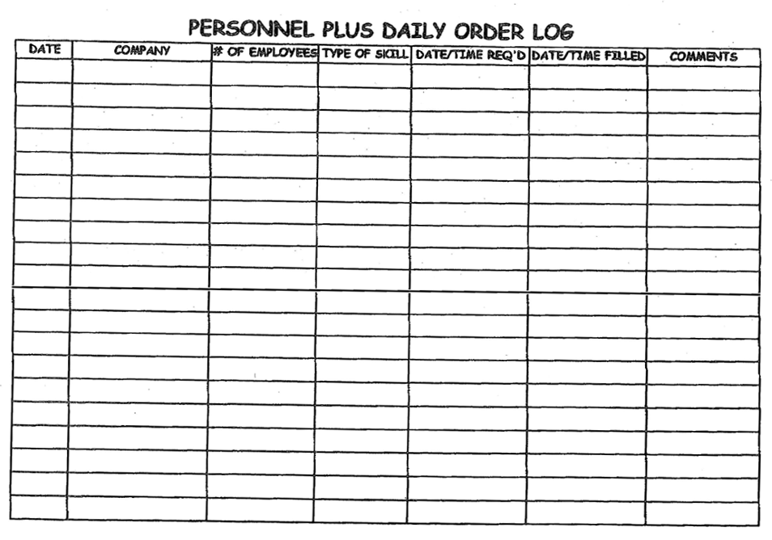

# Daily Sales Calls

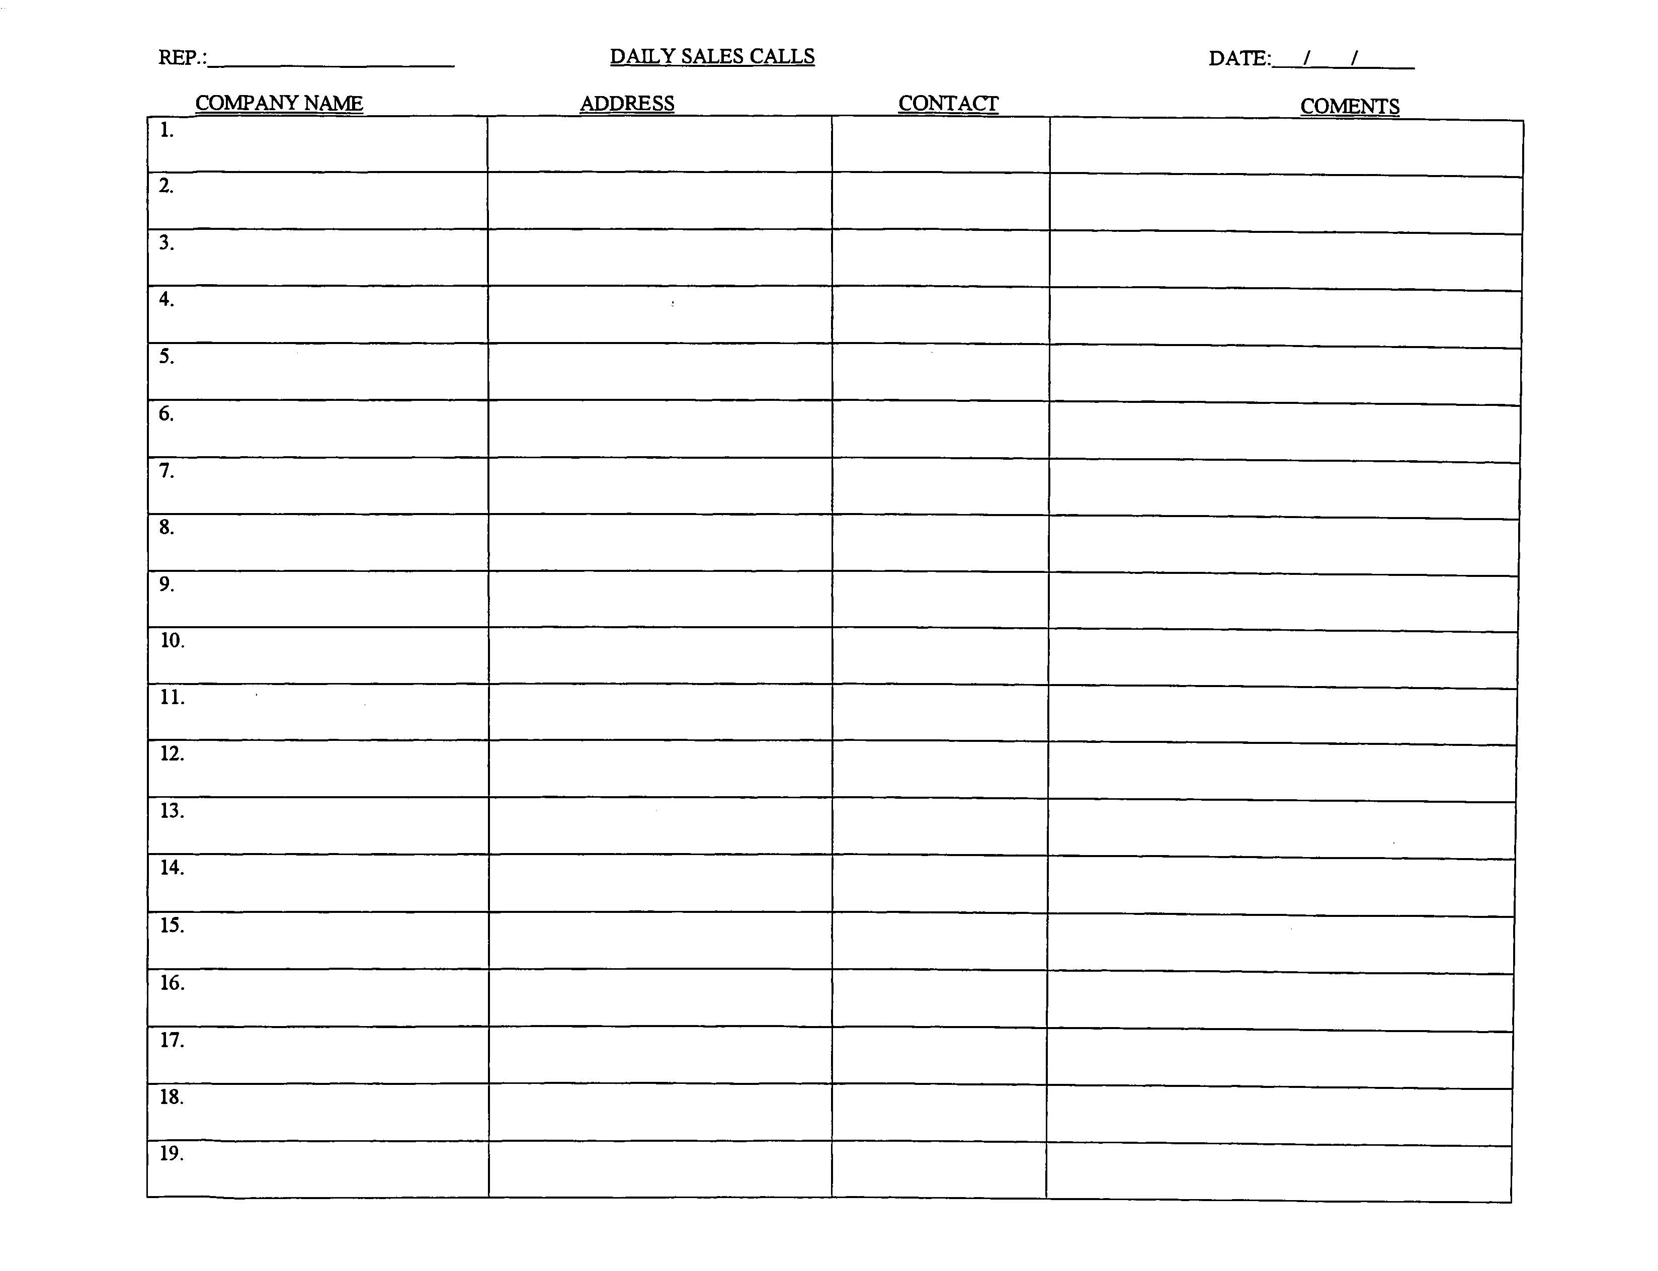

# Agenda for Staff Meetings

# Customer Satisfaction Survey

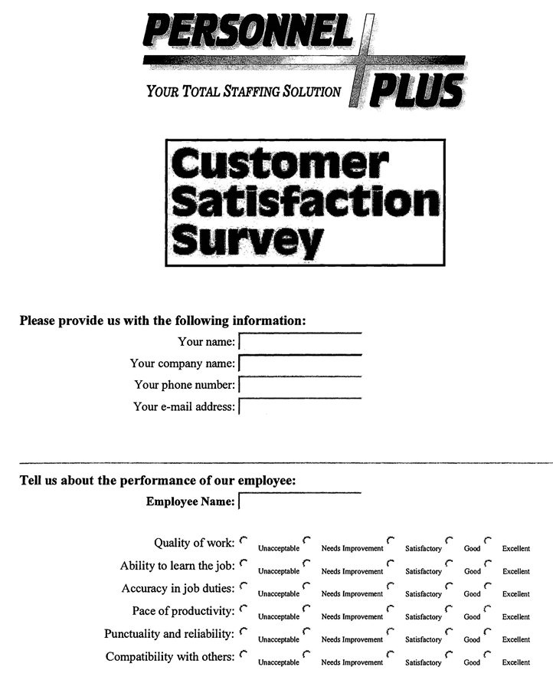

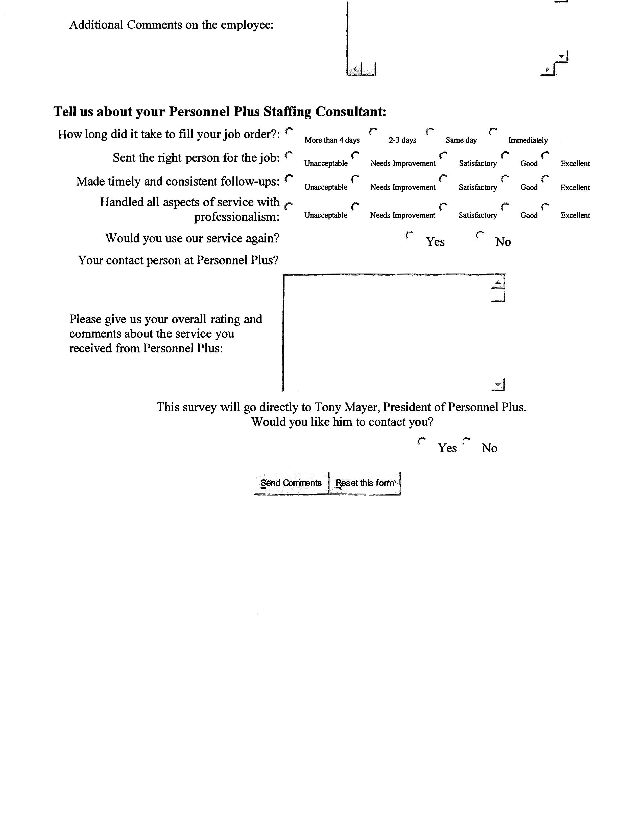

# Associate Work History

# Marketing Status Report

# Daily Sales Calls

# Employee Evaluation

# Rating the Applicant

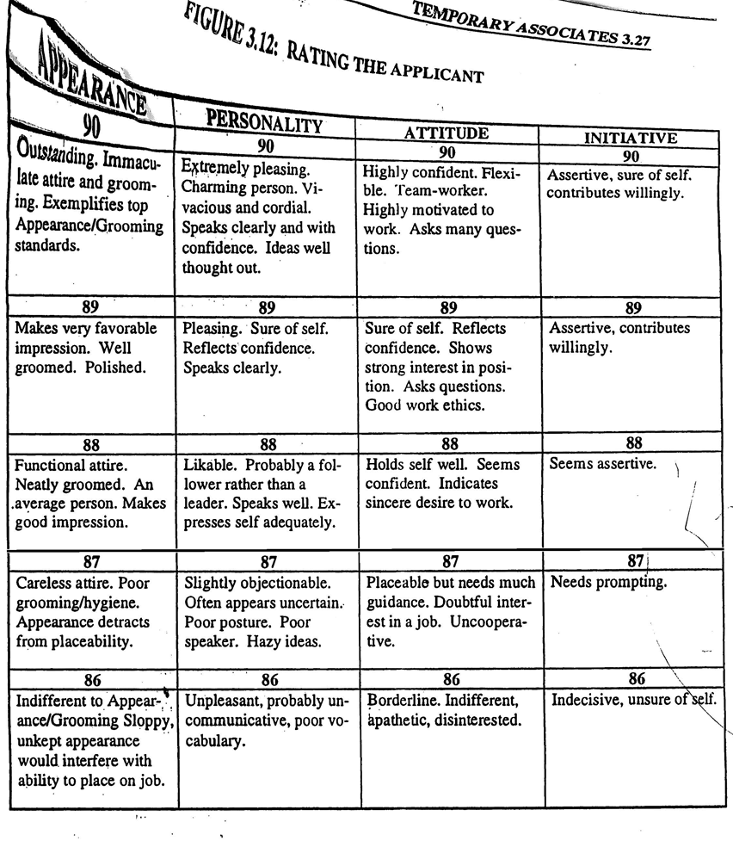

# 

# Physical Work Capacity Rate Graph

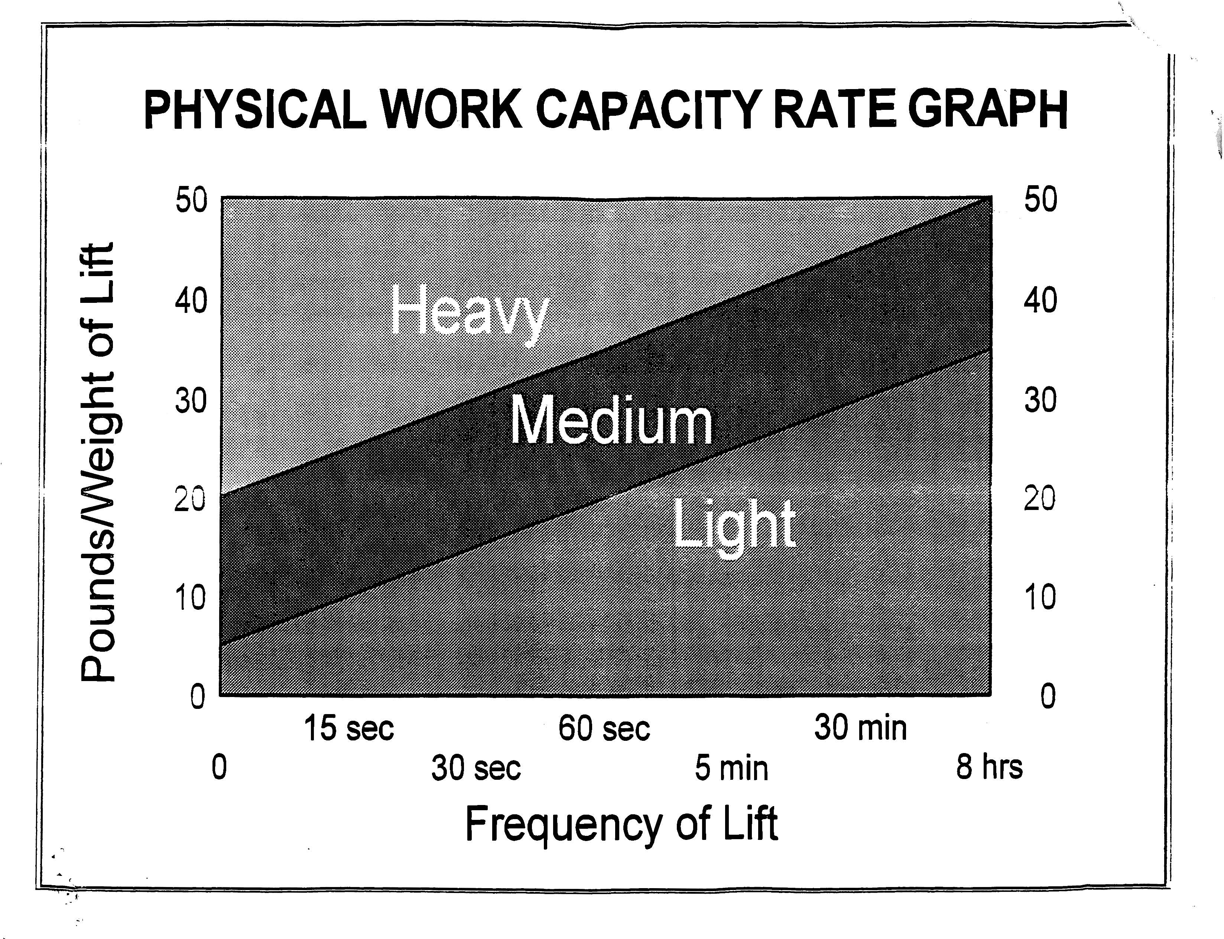

# Repetitive Motion Chart

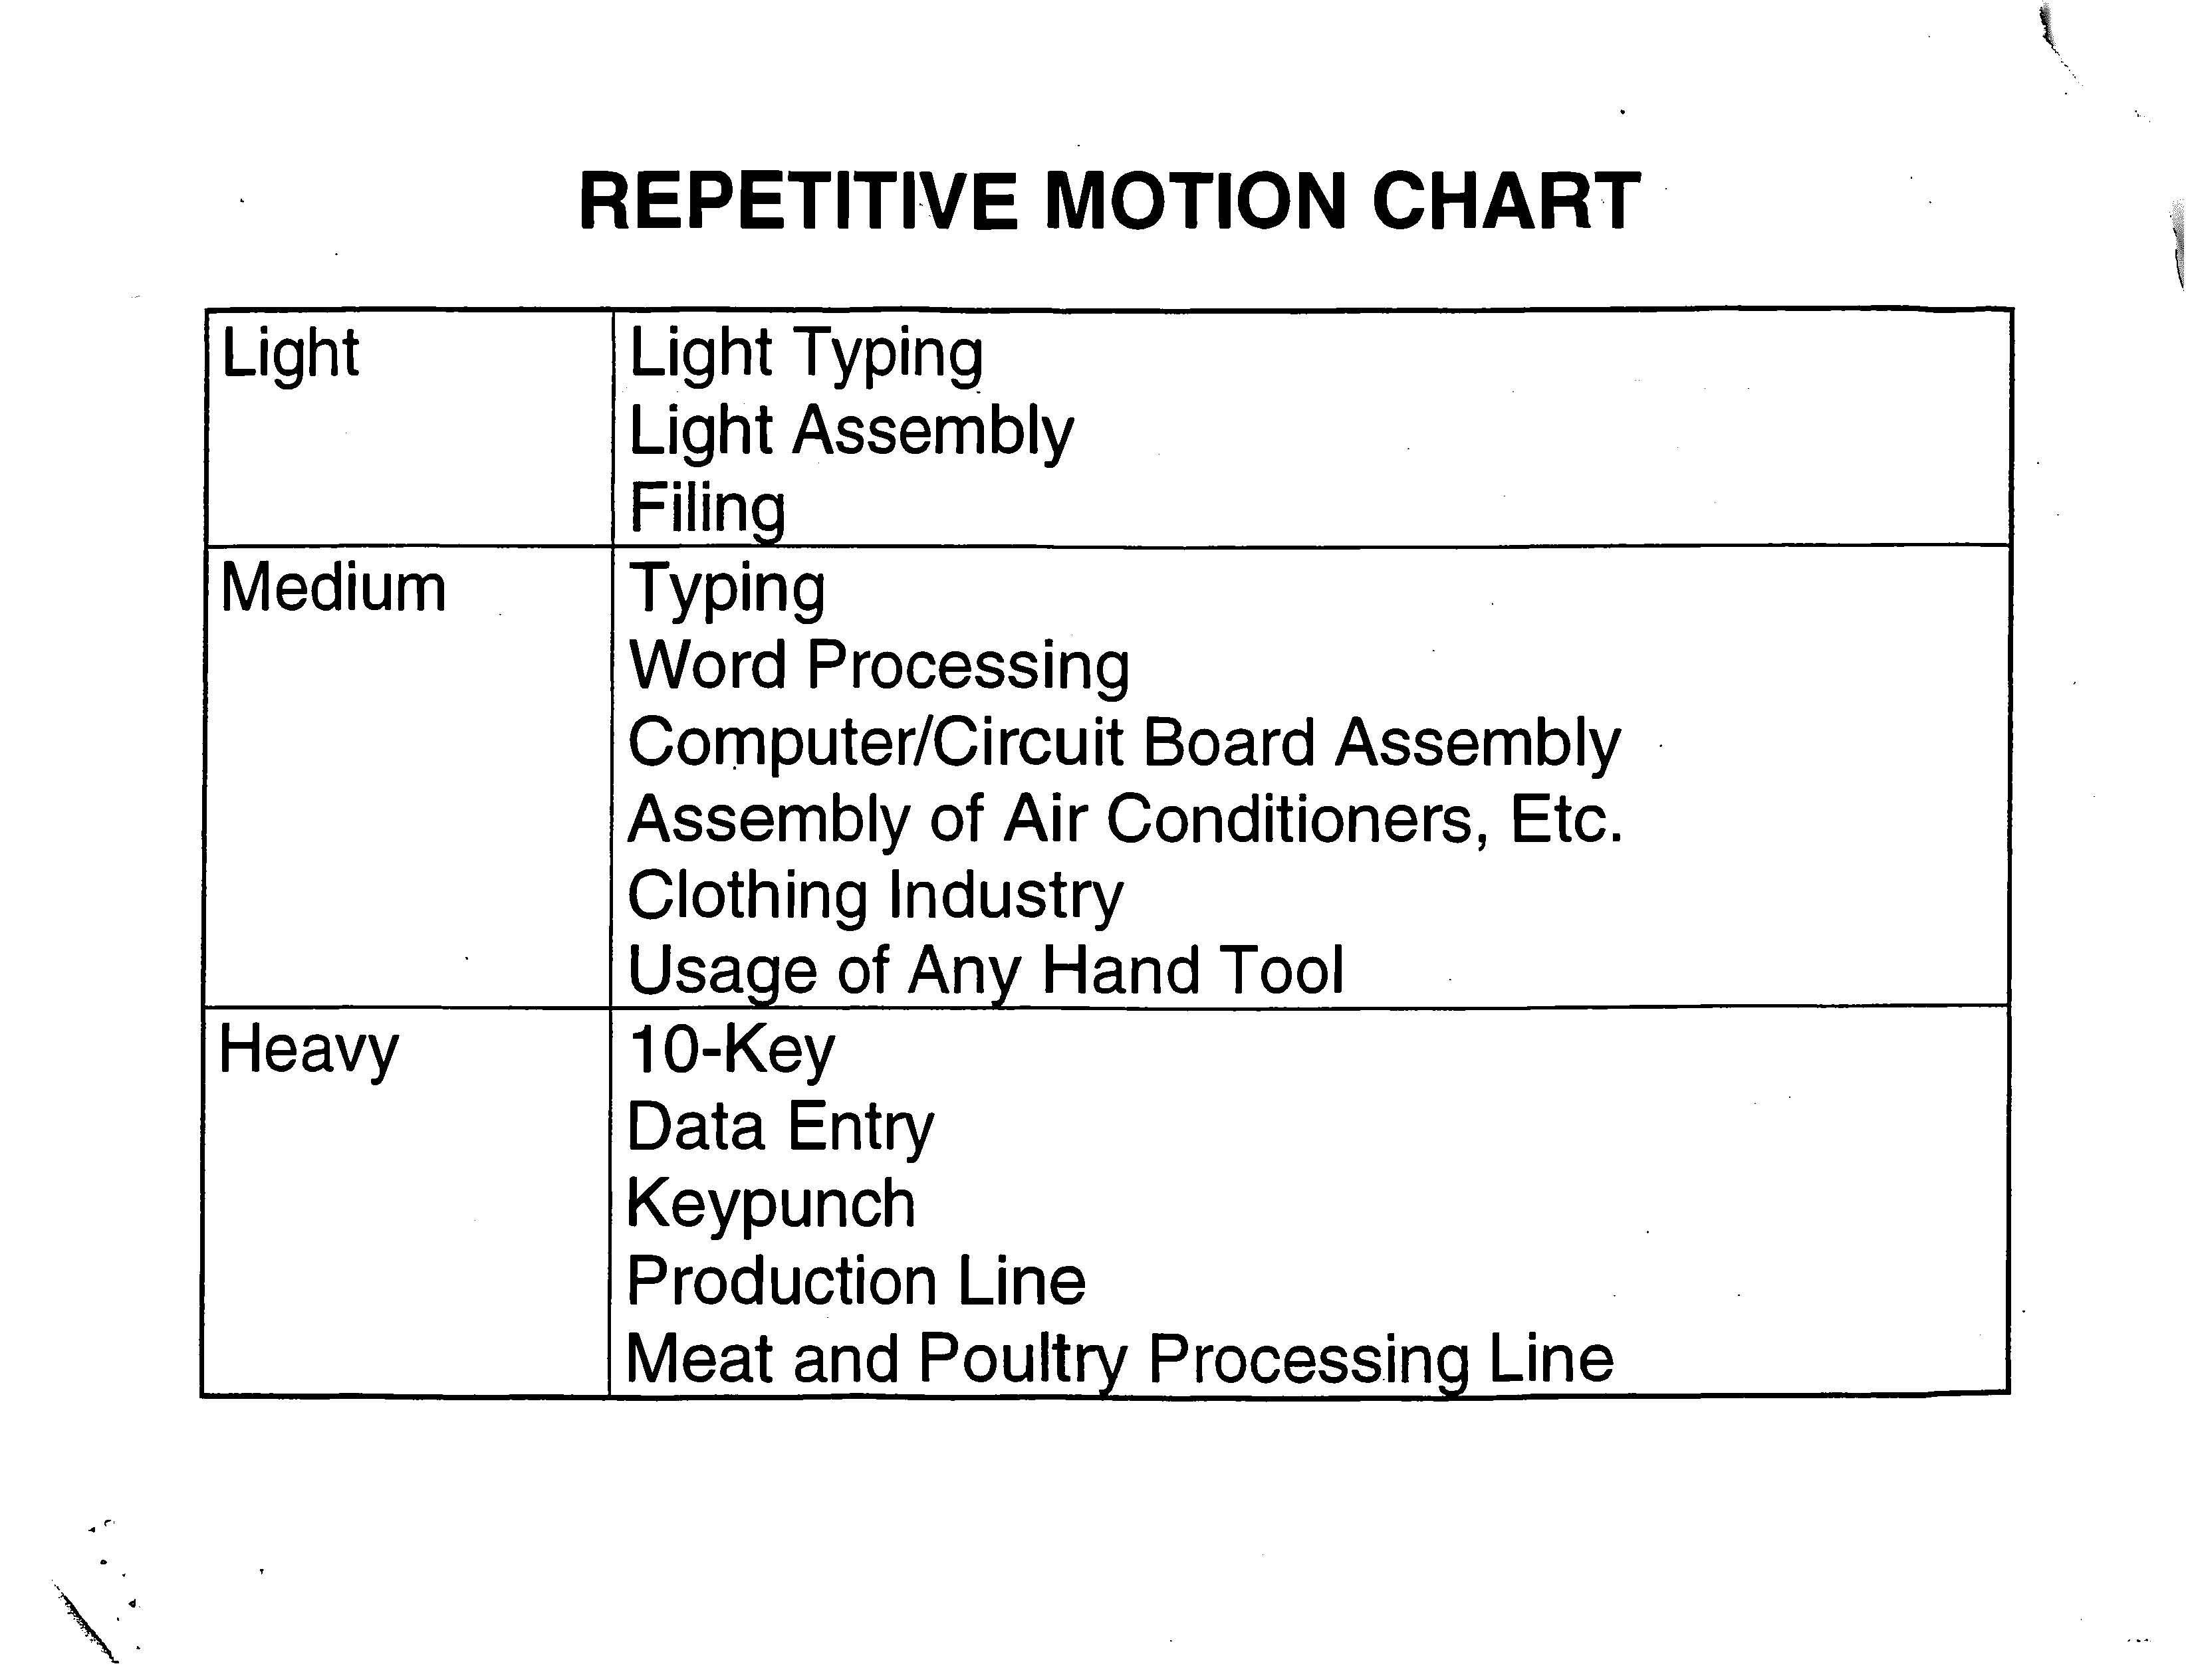

# Daily Order Logs

# Weekly Action Plan {internal}

# Ten Largest Area Employers

# 